

THE UNIVERSITY OF NAIROBI

SCHOOL OF COMPUTING AND INFORMATICS

B.Sc. COMPUTER SCIENCE

CSC 416 – PROJECT DOCUMENTATION

**AUTOMATED GREENHOUSE MONITORING SYSTEM**

**(TEMPERATURE AND HUMIDITY CONTROL)**

KANG’ALIA ISAAC NYAMU

P15/1325/2011

SUPERVISOR: PROF. OKELO ODONGO

2014 – 2015

**Submitted in partial fulfillment of the Requirements of the Bachelor of Science in Computer Science**

# DECLARATION

I hereby declare that this project, as presented within this report, is entirely my own work. The work reported and undertaken in this report has been executed by me except where explicitly stated otherwise in text. I affirm that this project has not been presented for any other University award.

**Name: __________________________KANG’ALIA ISAAC NYAMU__________________________**

**Registration Number: ___________________P15/1325/2011__________________________________**

**Signature: ___________________________________________________________________________**

**Date: _______________________________________________________________________________**

This project has been submitted in partial fulfillment of the requirements of the Bachelor of Science in Computer Science of the University of Nairobi and has been done with full support of my Supervisor.

**Name: _________________________ PROF. OKELO ODONGO______________________________**

**Signature: ___________________________ ________________________________________________**

**Date: ______________________________________________________________________________**

# DEDICATION

I dedicate this project to The Almighty God, adoring family and endearing friends

# ABSTRACT

For a very long time agriculture in Kenya has been one of the main economic activities. Recent developments in this sector has seen the rise of revolutionary technologies such as land reclamation practices like irrigation, afforestation and re-afforestation, research and development in disease and pest resistant crops, agricultural mechanization, animal cross-breeding among others. The most recent of these technologies, and which is quickly gaining popularity in the country, is the introduction of greenhouses and greenhouse technology. Chief among these technologies that has attracted the keen interest of many stakeholders is greenhouse automation. So far, there have been many successes in affordable automation of irrigation and fertigation processes in the country, and only recently has there been efforts expressed towards automation of temperature and humidity control. This has been evidenced by several projects in the country that have tried to implement this with the key selling points in mind being affordability, efficiency and convenience.

# ACKNOWLEDGEMENTS

I would like to thank my Supervisor Prof. Okelo Odongo for the compelling support in the implementation of this project.

I would also like to thank Derrick Mugasia from the Fab Lab for his patience and assistance in the designing and modelling of the greenhouse model.

I would like to also appreciate my parents for their support all the way. It was valuable and priceless!

Finally, I would like to acknowledge and appreciate the knowledge and experience acquired from the School of Computing and Informatics of the University of Nairobi.

Table of Contents

DECLARATION 2

DEDICATION 3

ABSTRACT 4

ACKNOWLEDGEMENTS 5

Table of Figures 8

Chapter 1: Introduction 9

1.1 Background Information 9

1.2 Problem Statement 9

1.3 Justification 9

1.4 Goals and Objectives 10

1.4.1 Main Aim of the Project 10

1.4.2 System Objectives 10

1.4.3 Research Objectives 10

1.4.4 System Development Objectives 10

1.5 Basic Assumptions 11

Chapter 2: Literature Review 12

2.1 The Current State in the Agribusiness Sector 12

2.2 Recent Efforts 12

2.2.1 Illuminium Greenhouses Limited 13

2.2.2 Tech Team 13

2.2.3 AgriSoft Solutions 13

2.2.4 FarmPal & FarmDrive 13

Chapter 3: Methodology 14

3.1 Approach 14

3.2 Methodology 14

3.3 Constraints 15

Chapter 4: System Analysis and Design 16

4.1 System Analysis 16

4.1.1 The General Structure 16

4.1.2 Data Collection 16

4.1.3 Configuration 17

4.1.4 Monitoring and Control 18

4.1.5 Fail-safes, Troubleshooting and Maintenance 18

4.2 Use-Case Diagram 19

4.3 Process Flow Diagram 20

4.4 System Architecture and Design 21

4.5 The Prototype and Technical Information 21

4.5.1 The Prototype 21

4.5.2 Technical Information of the Main Components 22

Chapter 5: Implementation 24

5.1 Hooking up the DHT11, the LM35 Sensors and the LCD 24

5.2 The Sketch of the Housing (with suggested dimensions – courtesy of FabLab) 26

Chapter 6: Conclusion 30

6.1 Achievements 30

6.2 Limitations 30

6.3 Further Work 30

Appendix 30

Appendix A: References 30

Appendix C: Sample Code 30

# Table of Figures

**Figure 3.1.1: The Rapid Application Development Model** 15

**Figure 4.1.1: Software Flow Diagram of the Data Acquisition Process** 17

**Figure 5.2.1: Figure showing the perspective view of the model greenhouse (Courtesy of SketchUp)** 26

**Figure 5.2.3: Rear View of the model green-house (Courtesy of SketchUp)** 28

**Figure 5.2.4: The housing of the micro-controller and the humidifier (Courtesy of SketchUp)** 29

**Figure 6.1.1: Some sample code for the DHT11 Library (Courtesy of Arduino Playground (http://playground.arduino.cc/Main/DHT11Lib))** 31

**Figure 6.1.2: My custom library (WIP) - the clock** 31

# Chapter 1: Introduction

## Background Information

Greenhouse farming is an agricultural technology that encompasses a greenhouse, which is a structural building with different types of covering materials, such as a glass or plastic roof and frequently glass or plastic walls. Incoming visible sunshine is absorbed inside the structure and it heats up. Air warmed by the heat from warmed interior surfaces is retained in the building by the roof and wall. The air that is warmed near the ground is prevented from rising indefinitely and flowing away. This allows for greater control over the growing environment of plants. Depending upon the technical specification of a greenhouse, key factors which may be controlled include temperature, levels of light and shade, irrigation, fertilizer application, and atmospheric humidity. Greenhouses may be used to overcome shortcomings in the growing qualities of a piece of land, such as a short growing season or poor light levels, and they can thereby improve food production in marginal environments.

Greenhouse technology is a new phenomenon in East Africa and has become particularly popular in Kenya. Many agri-businesses have set up shop here and are offering a wide range of solutions, some of which include agro-chemicals and fertilizers, irrigation solutions, seeds, greenhouses, investment advice, sales and marketing among many others. In general, solutions specific to greenhouse technology include heating systems, control systems, irrigation systems, fertilizer dosing systems, project design, integration and installation, drainage water recycling, and greenhouse accessories.

Most of these solutions encompass some form of automation for instance water flow control, temperature control, humidity control, light intensity control, soil pH control and drainage control. The importance of controlling these processes is to reduce human capital, increase accuracy and efficiency and maximize output and ultimately increase profit margins of produce.

## Problem Statement

This project intends to automate temperature and humidity control within the greenhouse environment, while optimizing them specific to a particular crop, throughout its entire growth cycle.

## Justification

Automation solutions have been provided in many greenhouse systems by several agri-business companies in Kenya including Amiran Kenya and Bosman Engineering Kenya Ltd. The most common type of these systems and which has also been tailored for open farming is the automated irrigation system, particularly the drip system, a technology advanced by Israel. This system comes with both water control and fertilizer control (fertigation) and it is aimed at minimizing water wastage by effectively utilizing the little water resources available, optimizing the fertigation process to ultimately increase crop efficiency hence maximizing produce and consequently increasing profit returns. In this regard, several projects aimed at making these systems available and affordable to the lower income farmers, especially those practicing small-scale farming, have been deployed in the country and around the region and there has been significant progress in realizing this effort.

Bearing this in mind, we can observe that little effort has been made in automating convenient, efficient and affordable temperature and humidity control processes for the greenhouse. In fact, only just recently have there been noticeable efforts to achieve this through several projects.

## Goals and Objectives

### Main Aim of the Project

To develop an affordable, fully automated system to optimize temperature and humidity conditions within the greenhouse, with minimal, if not none, human input.

### System Objectives

This project hopes to achieve efficiency by autonomously optimize temperature and humidity conditions within the greenhouse. There is need to improve the quality of produce and to increase crop efficiency. Minimal input will be required from the farmer towards crop production. This system should be able to serve persons without technical or even agricultural knowledge. This system is expected to be an affordable solution, even whilst maintaining efficiency and quality. Significant profit should be realized in the long-run. The system also aims at providing for more components to be added to it, thus scaling up the functionality. Finally the system should be easy to customize according to the farmer’s requirements

### Research Objectives

Some of the research for the development of the Automated Greenhouse Monitoring (Temperature and Humidity Control) System will be in sensor technology and how it can be applied in the context of greenhouse automation, the Arduino and other microcontrollers and hardware interfacing, the impact of greenhouse automation to agriculture and the Kenyan economy and the potential, feasibility and scalability of greenhouse automation in the region.

### System Development Objectives

During the development of the prototype for the Automated Greenhouse Monitoring (Temperature and Humidity Control) System, the following were established as some of the system development objectives:

1. Perform a requirements analysis, system specifications analysis and feasibility study for the system.
2. Research on the technologies, resources and materials required to develop a fully automated temperature and humidity monitoring system for the greenhouse.
3. Estimate the budget required to cover the expenses for the prototype and acquire the materials and other resources.
4. Come up with the conceptual design, process flow design, structural design, logical design and schematics for the system.
5. Develop a working prototype to demonstrate the system.

## Basic Assumptions

In implementing the project, some assumptions were made. Other automated processes such as irrigation, fertigation and light intensity control were assumed to be in the system and functioning adequately. One type of crop will be grown at any one time in the greenhouse.

# Chapter 2: Literature Review

Countless irrigation projects have been developed and refined over time and recent advancements have seen the fertigation process added to the functionality. Of course other control processes have also been automated. These include temperature, humidity, light intensity, drainage and water recycling (especially in hydroponics), process monitoring and security. Most of these functionalities are so advanced and costly, given the equipment used to implement them, that they are not economically feasible to the small-scale farmers and low-income earners practicing greenhouse farming. Unlike the irrigation process, these processes, in particular temperature and humidity control are only limited to greenhouses – they are not adaptable to open farming. However, a lot of research has gone into automating affordable temperature and humidity control so that it is economically sensible to the lower-end target market.



## The Current State in the Agribusiness Sector

Amiran Kenya, an Israeli-based company and also a member of the Balton CP group of companies, owns a 90% market share in the agri-business sector. They offer a wide range of solutions to varied classes of clientele to suit their specific agricultural needs and in particular, the greenhouse technology. Quite notable, however, is the fact that greenhouse temperature and humidity control automation services are only limited to those who can afford it as they don’t come cheap. One of the innovative systems they have developed is the computerized irrigation system which performs water filtration, fertigation and optimizes water irrigation by means of an oscillator.

HESE, in collaboration with Mavuuno Greenhouses have set up to provide greenhouses that are affordable, durable and expandable while simultaneously supporting and promoting organic farming and a green lifestyle. There is however no documented evidence that they also offer automated services.

Bosman Engineering Kenya Ltd. supplies everything required to achieve energy and water savings and to optimize the greenhouse climate with the help of simple-to-use-but-not-so-cheap automation solutions. However, they have set up several projects within the region to try and make these solutions more affordable to the lower-end farmers.

Green Farming, a Netherlands-based company, with notable partners such as C&J Bosman BV, Genap, Hatenboer-Water and the governments of Ethiopia and Kenya have set up projects and logistics to support horticulture in these countries and the Netherlands.

NEtafim have a policy to establish the correct balance between the farmer’s needs and factors like technology, agro-economics, and crop requirements as far as green-housing goes.

## Recent Efforts

Recently, there have been innovative solutions that have been made towards automating temperature and humidity monitoring and control in an affordable and an informative manner.

### Illuminium Greenhouses Limited

Illuminium Greenhouses Ltd have come up with the Mkulima Hodari technology. The Operations Manager, Mr. Taita Ng’etich said they are targeting small-scale farmers and especially those in urban areas. The kit collects both weather data and internal conditions within the greenhouse itself and that information helps the farmer make informed decisions. Conditions monitored are temperature, humidity and soil moisture. A complete kit is expected to retail at USD230 when it is rolled out to the market. However, very little automation is achieved as most processes are remote controlled (RC) by use of a phone app.

### Tech Team

Tech Team, composed of three students from the School of Engineering at Kenyatta University - Anthony Mburu, Charles Nyagaka and Japheth Kipkirui, came up with a product called Smart Shamba which came up 5th position at the PivotEast Galileo Competition organized by Intel East Africa. Their technology is composed of a control box with a memory card for data storage and logging and an LCD for displaying status information. Conditions monitored include temperature, light, humidity and soil moisture but they hope to also be able to monitor soil pH, water level in the tank and check against intruders in future modifications. Unfortunately, they’ve programmed the control box so that it controls conditions for a specific crop at any one time. So if one wants to grow a different crop they have to adjust these conditions by hard-coding the logic into the control-box every single time this happens.

### AgriSoft Solutions

Agrisoft Solutions’ team leader, Elijah Mwathi, says that the main focus of the company is on developing mobile solutions in agriculture.

### FarmPal & FarmDrive

FarmPal have also developed a phone app to give farmers useful and relevant agricultural information via SMS service. Greenhouse Pro is a mobile app that presents the farmer with relevant information pertaining to greenhouse farming. Finally, FarmDrive have focused themselves on equipping small holder farmers with helpful financial services.

# Chapter 3: Methodology



## Approach

The approach to be used will be the iterative where certain aspects of the development process will be revisited and reviewed for purposes of staying within the scope, ensuring accuracy of the system in terms of its specifications, satisfying user requirements and minimizing risk.

## Methodology

The methodology that will be used to implement this approach is the **RAPID APPLICATION DEVELOPMENT** methodology (RAD)

The basic principles of this methodology are fast development and delivery of a high quality system at a relatively low investment cost, its output being production software, as opposed to a throwaway prototype which is not cost-effective and the production of documentation necessary to facilitate future development and maintenance. Also, there is a lot of project control which involves prioritizing development and defining delivery deadlines. If the project starts to slip, emphasis is on reducing requirements, to fit the time-box, not in increasing the deadline. Key emphasis is on fulfilling the business, while technological excellence is of lesser importance. Finally, it aims to produce high-quality systems quickly, primarily through the use of iterative prototyping (at any stage of development), active user involvement, and computerized development tools. These tools may include Graphical User Interface (GUI) builders, Computer Aided Software Engineering (CASE) tools, Database Management System (DBMS), fourth-generation programming languages, code generators, and object-oriented techniques.

Therefore, it is ideal for projects with short development duration. The allocated time is approximately six months so this will suffice. Functionality of the system will really have to be clearly visible through the interfaces created. One of the objectives of this project is scalability. Therefor continuity of core development team can be easily maintained using this methodology. The aim is to design a comprehensive technical architecture that can be clearly defined for the final prototype to work. Which is why a huge amount of time will be spent in coming up with a functional conceptual, logical and architectural schematic for the system. Finally, key technical components will have to be tested to ensure accurate functionality.

However, there is the risk that the project may end up with more requirements than needed (gold-plating) – the workaround for this is the fact that the prototype for this project has been restricted to temperature, humidity and soil moisture optimization. In the event that this the scope may have to be extended, then only the web application and the GSM/GPRS modules will be added. The other potential drawback is for the designed system to lack scalability. The system however has the potential to be scaled to add more functionality but the prototype will be limited to a few of these. Since some modules will be implemented much earlier than others, well-defined interfaces will be required.

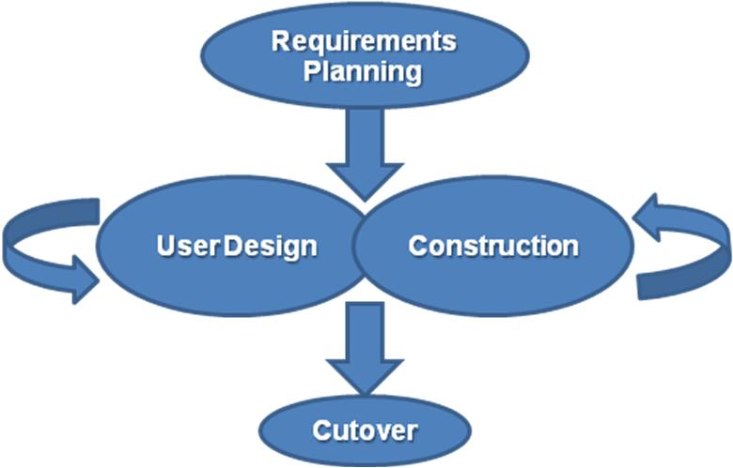

**Figure 3.1.1: The Rapid Application Development Model**

## Constraints

Advancement of the system to include further conditions and better control will be limited by the Arduino as it has a limited number of connections and functionalities. Although the use of the Arduino is feasible for the prototype, use of a microcontroller or multiple Arduinos can be recommended for bigger systems of a similar nature if these further enhancements are to be catered for. Cost issues are also a significant constraint. So far the estimated cost for this project is roughly KES 26,000. It is important to note that one of the major aims of this project is ultimately come up with a prototype which the small-scale farmers can afford.

# Chapter 4: System Analysis and Design



## System Analysis

### The General Structure

The entire setup will be comprised of a temperature and humidity sensor for collection of temperature and relative humidity reading respectively. These are relayed to the microcontroller which converts the analogue input into digital output that will be displayed on a screen and possibly logged for charting purposes. Based on some configured information, the microcontroller will intelligently analyze and compare the readings and act accordingly when the readings are higher or lower than the optimal readings. High and low readings will be indicated by means of LED lights. Control information is relayed from the microcontroller to several actuators mounted around the greenhouse to optimize temperature and humidity conditions. The assumption here is that there is already a properly working automated irrigation monitoring and control component.

### Data Collection

Temperature readings will be collected by an LM35 temperature sensor while humidity readings will be collected by a DHT11 or DHT22/35 sensor. Both the DHT11 and DHT22/35 work the same. The only difference though is that the DHT22/35 is more sensitive, making it a high precision temperature and humidity sensor. Both the temperature and humidity sensors will collect information as analogue signals which will be relayed to the microcontroller board and converted into digital output for display on some screen or, alternatively, on a more advanced setting, to the user’s phone of PC. These readings will be sent regularly depending on their calibration.

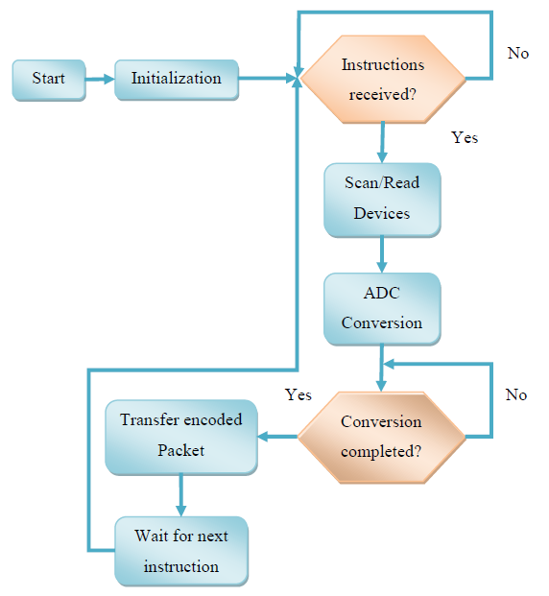

**Figure 4.1.1: Software Flow Diagram of the Data Acquisition Process**

### Configuration

There will be some form of a logic box where certain configurations will be made to guide the process of automation. The farmer will put into the logic box the following variables: the crop being grown in the greenhouse (customarily, only one crop can be grown at a time in the greenhouse or alternatively two or more crops with the similar growth requirements as well as growth patterns, seasons and durations can be grown in the same greenhouse); the stage of growth the crop is at and the date and time this is done.

The logic box contains information/ data necessary to accommodate a wide variety of crops and at different stages of their growth. Essentially, it is a logical component of the system and shall be implemented as a code file. The microcontroller then implements a clocking function by doing the following:

1. referencing the values given to it by the logic box as base data with which the system automation process will be implemented
2. using values captured by the sensors while referencing the base data to automate optimal conditions within the greenhouse throughout the growth cycle of the crop as these optimal conditions change as the crop grows
3. keeping track of changes of values in the base data and implement the necessary counter-measures to automate optimization

### Monitoring and Control

The greenhouse is fitted with an input fan with variable speed, an output fan, a humidifier component and a heater mounted with a fan for distribution of heat throughout the greenhouse. A variation to this setup is a motorized roof-door to act in place of the input fan. When the temperature is high, the heater is turned off if it is on and the input and output fans are turned on. If the temperature is low the input fan is turned down, the heater and its fan turned up and the output fan turned up to increase distribution of heat. Should humidity go up, the humidifier is turned off, the heater is turned down, the input and exhaust fans turned up until such a point that the humidity levels have gone down that the heater is turned up while the fans are still running to enhance distribution of warm dry air. However, if the humidity is low the humidifier is turned up and the input fan turned up and the exhaust fan turned down to distribute the moisture, after which the heater is turned up.

At the same time, the microcontroller collects status information from the sensors and the actuators and notifies the farmer when: data is not successfully logged to the microcontroller by the sensors, signals have or have not been successfully sent to the actuators, and the actuators have malfunctioned. These are indicated by the status LEDs and alarm mounted in the circuit. Upon perception of these notification signals the farmer can then act accordingly.

A water mister is used as a humidifier and vapor is circulated throughout the greenhouse by means of the input fan. The optimum humidity levels for most greenhouse crops is about 70 per cent and below as this will help in curtailing plant diseases brought about by high humidity levels.

For the heating process a vented heater is used, because it is mounted with a fan to distribute heat throughout the greenhouse. It is also encased in an aluminized or a stainless steel heating chamber for longer life in the moist, corrosive atmosphere of the greenhouse. A vented heater produces dry air which is less humid, thereby minimizing the chances for plant disease and subsequent crop degradation. It, however, consumes so much energy that it is more ideal to run it on LPG gas which is less costly. Heating not only raises the temperature conditions within the greenhouse, but also lowers the humidity.

### Fail-safes, Troubleshooting and Maintenance

As a fail-safe, the base data should be able to guide the system to know what conditions to optimize when, regardless of whether or not the system is powered up. This means that, if for instance power fails, the moment it is back up the system should be able to use the clocking function to pick up from the current state and not from the previous state it was in before the power loss. This is because whether the system is working or not, the crops still grow regardless. Also, as a fail-safe, and as a recommendation, there should be a back-up power source. Also, there should be a manual override in case the automation of the actuators fails.

## Use-Case Diagram

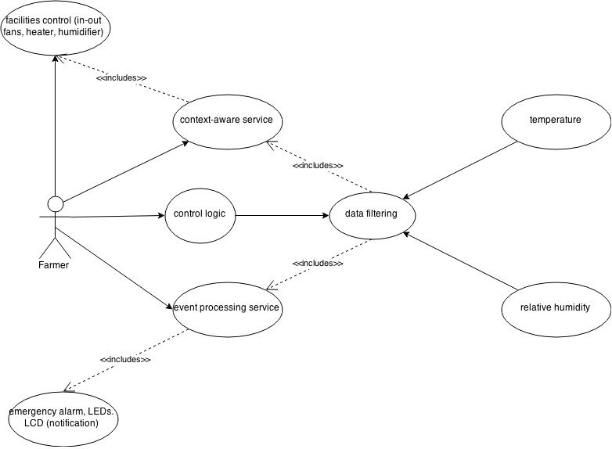

**Figure 4.2.1: Use Case Diagram showing the Automated Greenhouse Temperature and Humidity Control Processes**

## Process Flow Diagram

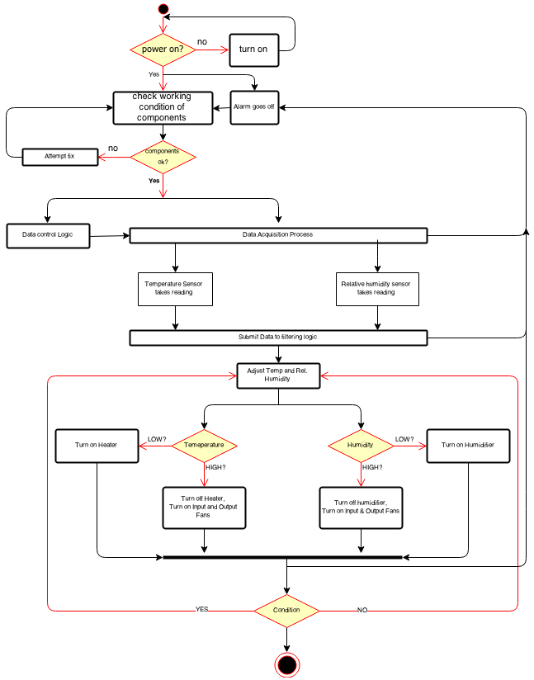

**Figure 4.3.1: Process Flowchart for the Automated Greenhouse Temperature and Humidity Control**

## System Architecture and Design

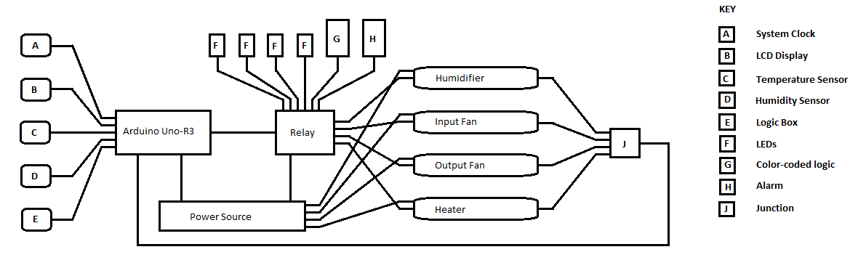

**Figure 4.4.1: General Architectural Design of the Automated Greenhouse Temperature and Humidity Control System**

## The Prototype and Technical Information

### The Prototype

To implement the prototype the following parts and components/materials/devices will be required:

1. A DHT 11 (humidity and temperature) sensor to collect humidity readings and send the values to the Arduino board
2. Jumper wires (male-male, female-female and male-female) for circuit connection throughout the entire contraption
3. Acrylic plastic or an alternative for the housing
4. A filament bulb to act as the heater
5. Arduino Uno R3 Board - to act as the micro-controller for the system
6. Resistors, Transistors and diodes for voltage control
7. Breadboard to extend the Arduino and other components
8. A 4-channel relay module to act as the switch
9. Two 92mm, brushless 12V DC, 0.1A fans, one to act as the intake fan for cooling, while the other as the exhaust fan for ventilation and both for air circulation
10. Mains power supply for the transformer that will power the actuators
11. A transformer with a 230-240V AC input and 12V AC output
12. A solenoid valve for channeling of humid vapor
13. A 1602 LCD with a PCF8574A I2C Serial adapter to display the readings
14. LEDs for indication of temperature and humidity readings higher than the operating optimum readings, command signals having been successfully sent to the relevant actuators and command signals having not been successfully sent to the relevant actuators

### Technical Information of the Main Components

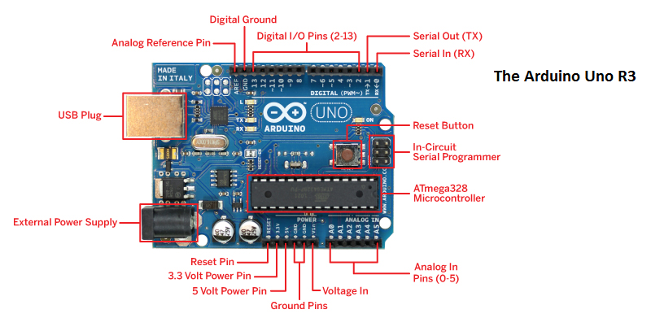

**Figure 4.5.1: The Arduino Uno Rev. 3**

The Arduino Uno R3 (Atmega328) microcontroller has 14 digital input/output pins, of which 6 can be used as PWN outputs 6 analog inputs, a 16MHz ceramic resonator, a USB connection, a power jack, an ICSP header and a reset button. It features an Atmega16U2 programmed as a USB-to-serial converter. It works on an operating voltage of 5V and a recommended input voltage range of 7 – 12V, a DC current per I/O pin of 40mA and a DC current for the 3.3V pin of 50mA, a flash memory of 32KB (with 0.5KB used for the bootloader), a static RAM of 2KB and an EEPROM of 1KB, and a clock speed of 16MHz. The board can also be powered via a USB connection. External power can come either from an AC-to-DC adapter or battery. The adapter can be connected by plugging a 2.1mm centre-positive plug into the board’s power jack. Leads from a battery can be inserted in the ground and voltage in pin headers of the power connector. The Arduino Uno has a resettable polyfuse that protects the computer’s USB ports from shorts and overcurrents.

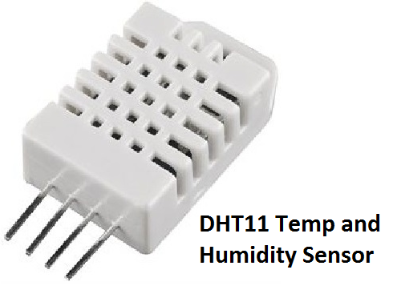The DHT11 is a basic ultra-low cost digital temperature and humidity sensor. It uses a capacitative humidity sensor and a thermistor to measure the surrounding air, and spits out a digital signal on the data pin (no analogue input pins are needed). It is fairly simple to use but requires careful timing to grab data. The only real downside to this sensor is that one can only get new data from it once every two seconds so when using its library, data can be up to 2 seconds old. A better alternative to this is the DHT22 which is much more sensitive hence highly precise. However, the DHT22 is quite expensive. So for purpose of the project the DHT11 will be used instead. The DHT11 can accommodate 3-5V power and I/O, uses up to 2.5mA of current during conversion, is good for 20-80% humidity readings with 5% accuracy, is good for 0-50˚C temperature readings ±2˚C accuracy and has no more than 1Hz sampling rate.

**Figure 4.5.2: The DHT11 Temperature and Humidity Sensor**

# Chapter 5: Implementation



## Hooking up the DHT11, the LM35 Sensors and the LCD

To start off with the implementation of the prototype a sketch showing how the LM35 and the DHT11 sensors were going to be connected in the circuit. The Arduino board can take a range of 5 – 12V voltage input. With the introduction of a 220V input/12V DC output transformer this can be achieved if the setup is to be standalone. Since code needed to be uploaded to the microcontroller voltage and current from the laptop was used. This provided a range of 5 – 12V input voltage. The LM35 gives an analog output whereas the DHT11 gives out a digital output.

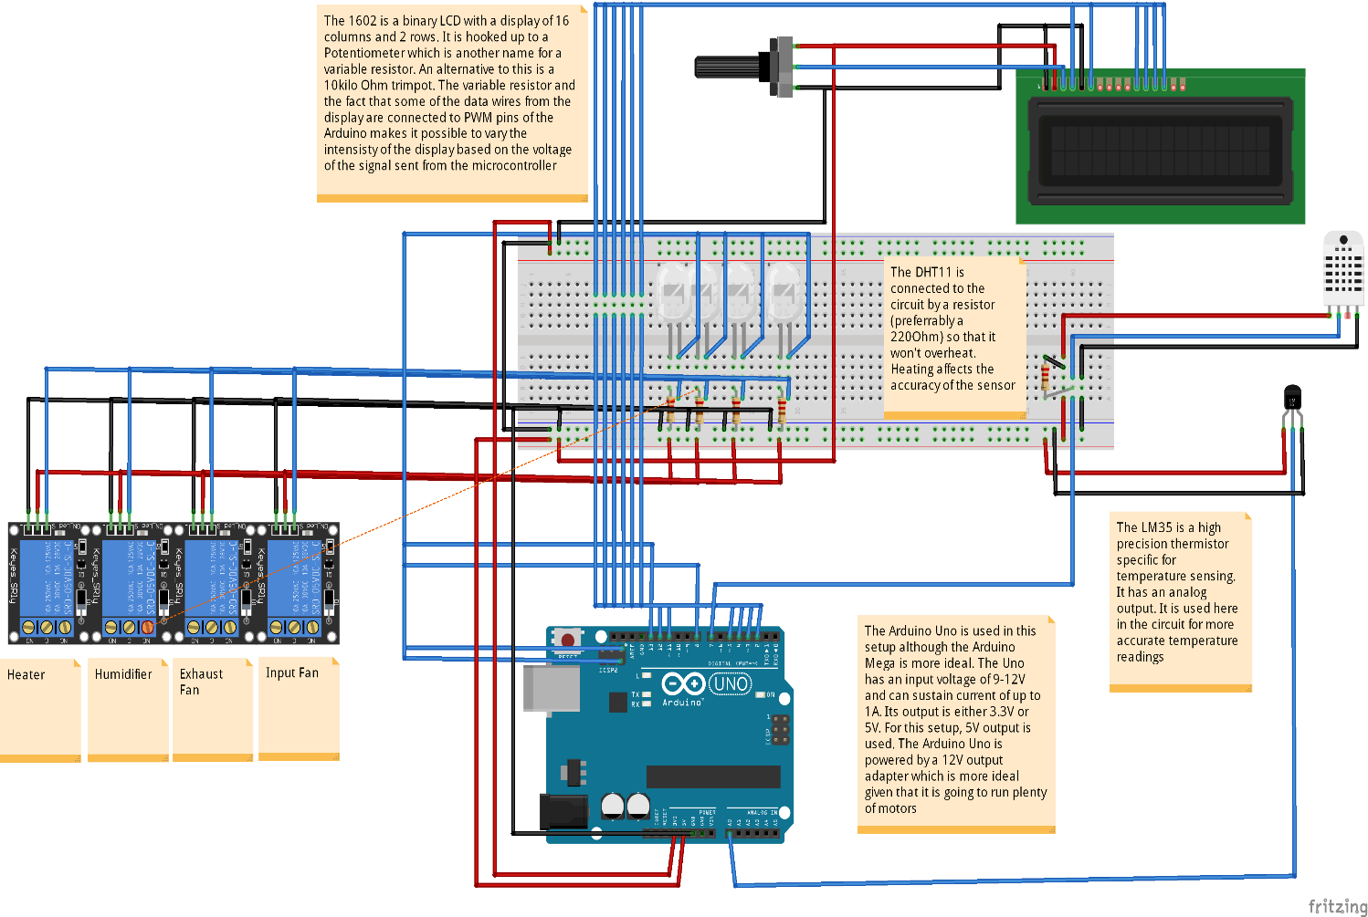

**Figure 5.1.1: Connecting the DHT11, the LM35 and the 1602 LCD in the circuit (Courtesy of Fritzing)**

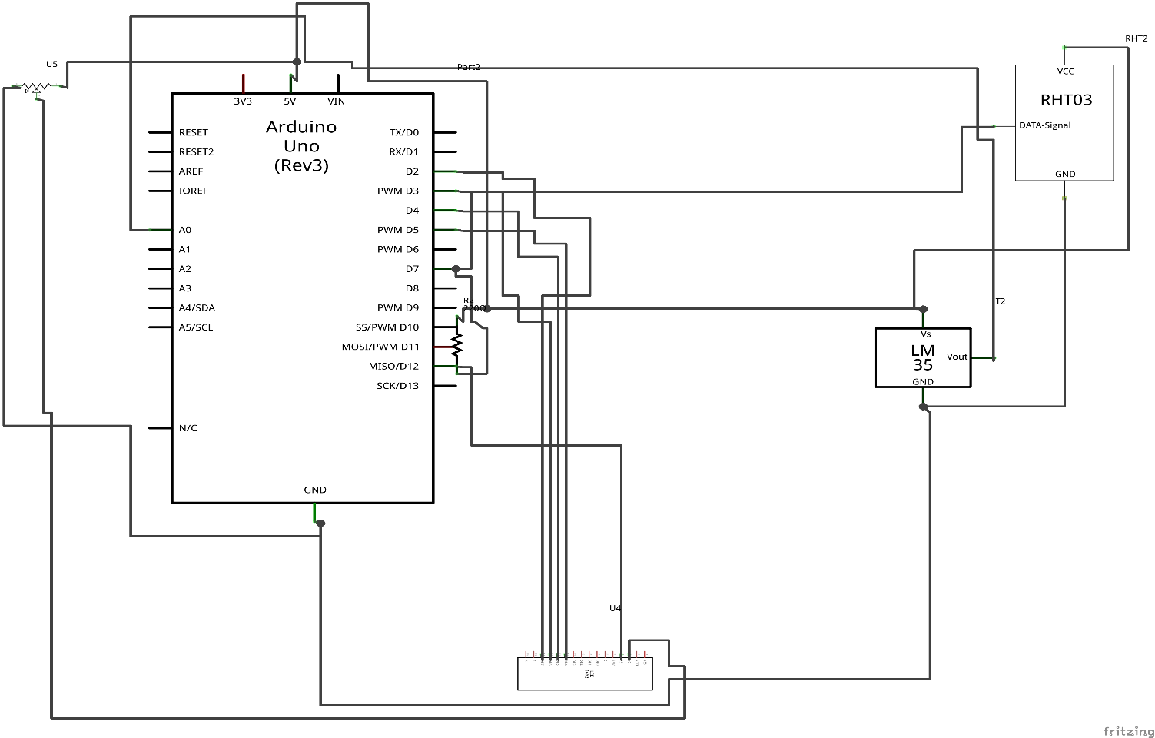

**Figure 5.1.2: Schematic of the circuit – LCD, DHT11 and LM35 (Courtesy of Fritzing)**

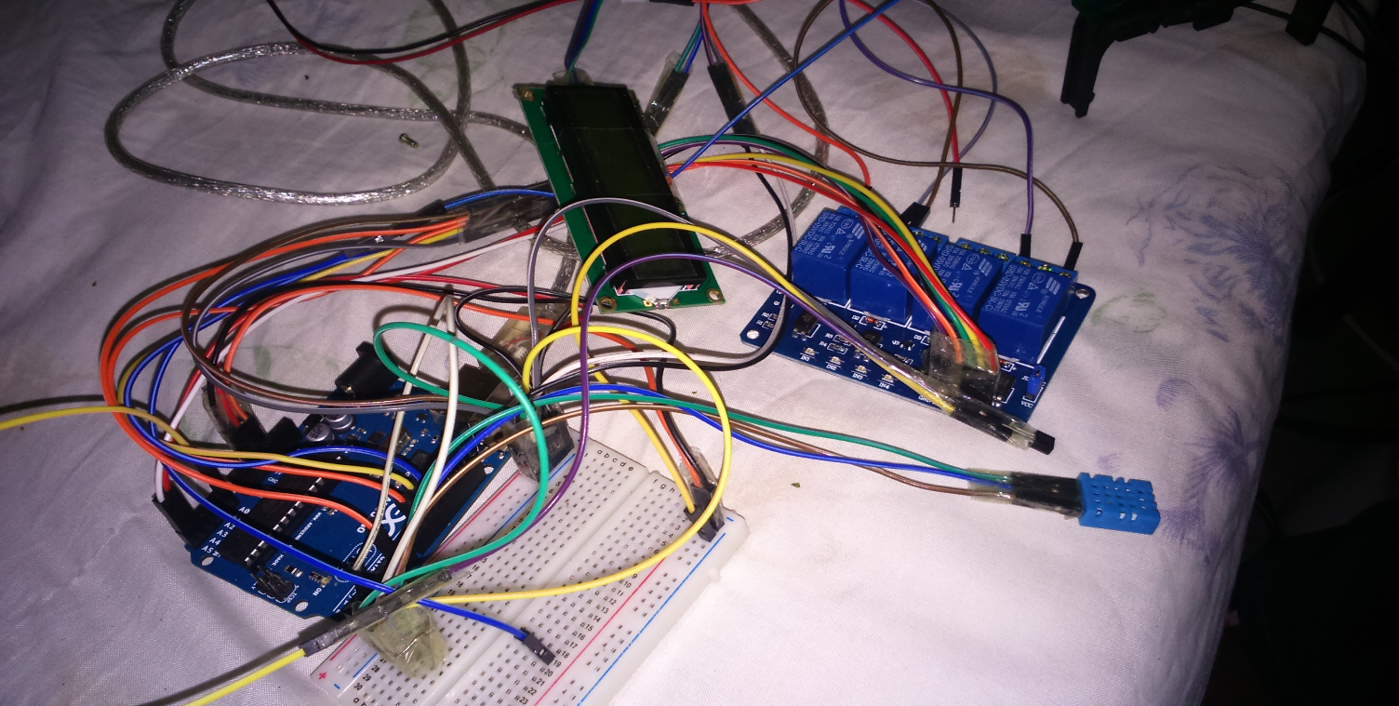

**Figure 5.1.3: Photo showing the LM35, the DHT11 and the 1602 LCD hooked to the breadboard and connected to the micro-controller**

## The Sketch of the Housing (with suggested dimensions – courtesy of FabLab)

**Figure 5.2.1: Figure showing the perspective view of the model greenhouse (Courtesy of SketchUp)**

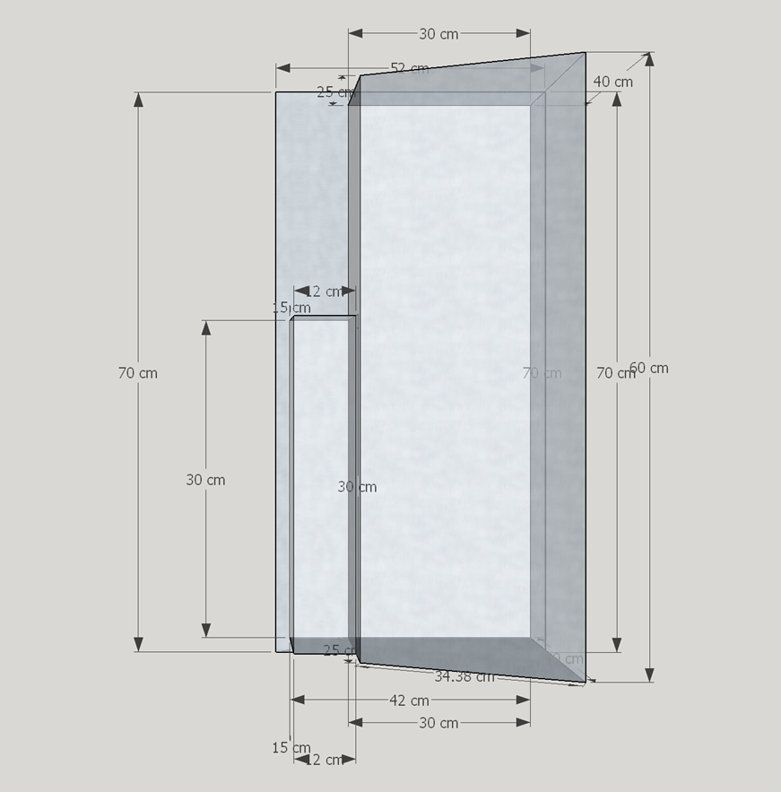**Figure 5.2.2: Top View of the model greenhouse(Courtesy of SketchUp)**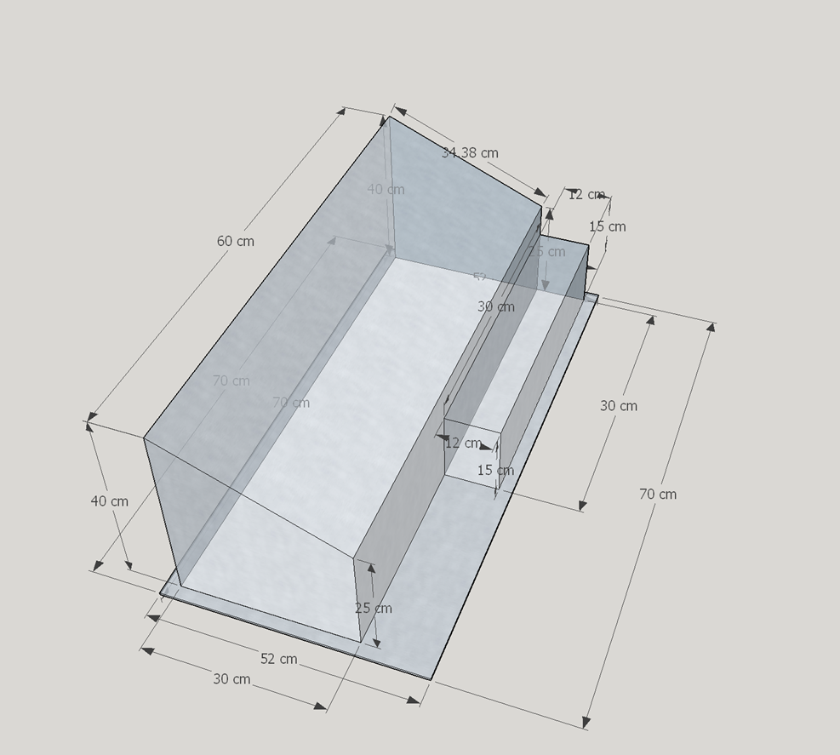

**Figure 5.2.3: Rear View of the model green-house (Courtesy of SketchUp)**

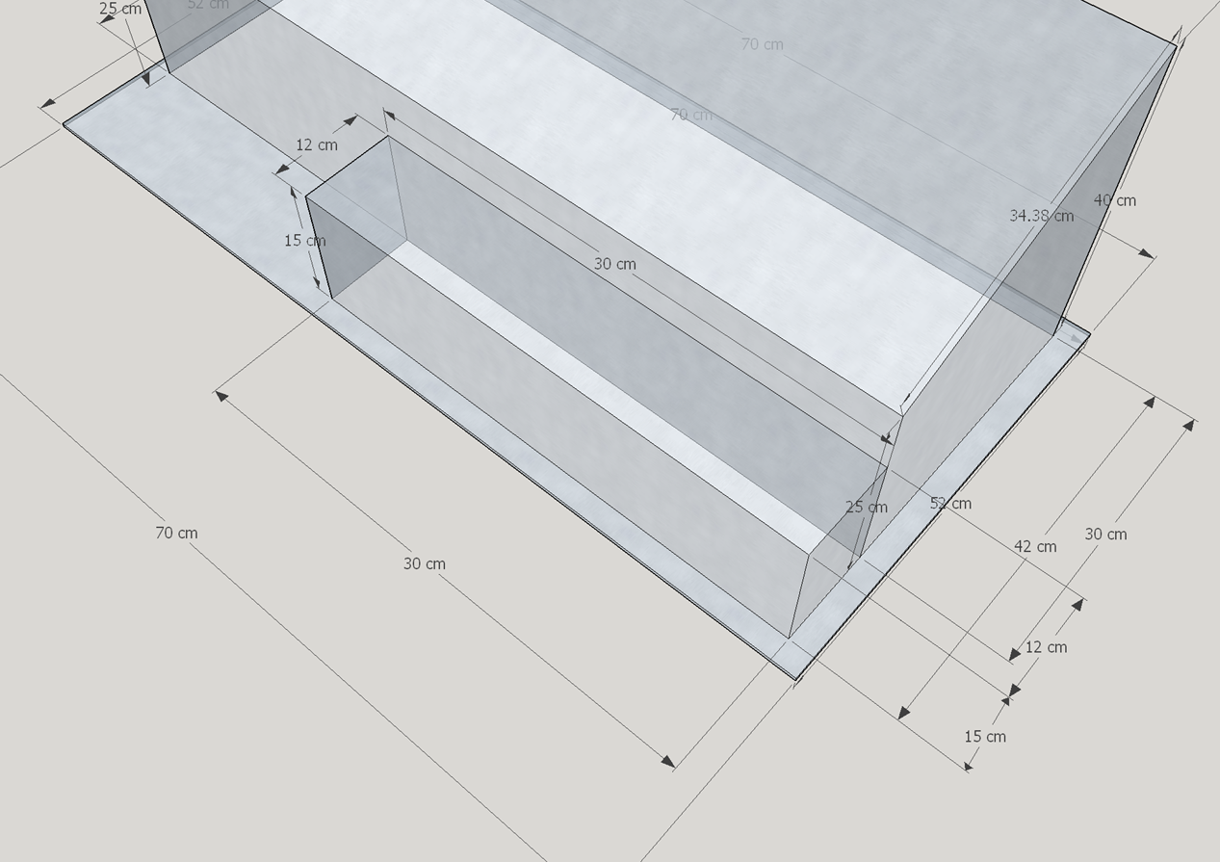

**Figure 5.2.4: The housing of the micro-controller and the humidifier (Courtesy of SketchUp)**

# Chapter 6: Conclusion



## Achievements

## Limitations

## Further Work

# Appendix

## Appendix A: References

Wikipedia (2014) *Greenhouse* [Online] Available from: <http://en.wikipedia.org/wiki/Greenhouse> [Accessed: 16th October 2014]

PHFamS-Africa (2014) *PHFamS-Africa* [Online] Available from: <http://phfamsafrica.com/> [Accessed: 16th October 2014]

Mavuuno greenhouses Inc (2014) *Mavuuno Greenhouses* [Online] Available from: <http://www.mavuunogreenhouses.com/> [Accessed: 16th October 2014]

Roza, C. (ed.), 2012, *Partners for Perfect Solutions – Connecting Horticultural Networks of the Netherlands, Kenya and Ethiopia,* Green Farming, Netherlands

Amiran Kenya (2012) Amiran [Online] Available from: <http://www.amirankenya.com/> [Accessed: 16th October 2014]

Amiran Kenya (2014) *Amiran’s Computerized Irrigation System that allows farms to grow more with Less* [Online] Available from: <http://www.amirankenya.com/index.php?option=com_content&view=article&id=407:amirans-computerized-irrigation-systems-that-allow-farms-to-grow-more-with-less&catid=40:headlines&Itemid=289> [Accessed: 16th October2014]

HumanIPO (2012) *African Farmers set for Turnaround as FarmPal promises better prospects* [Online] Available from: <http://www.humanipo.com/news/192/african-farmers-set-for-turnaround-as-farmpal-promises-better-prospects/> [Accessed: 16th October 2014]

## Appendix C: Sample Code

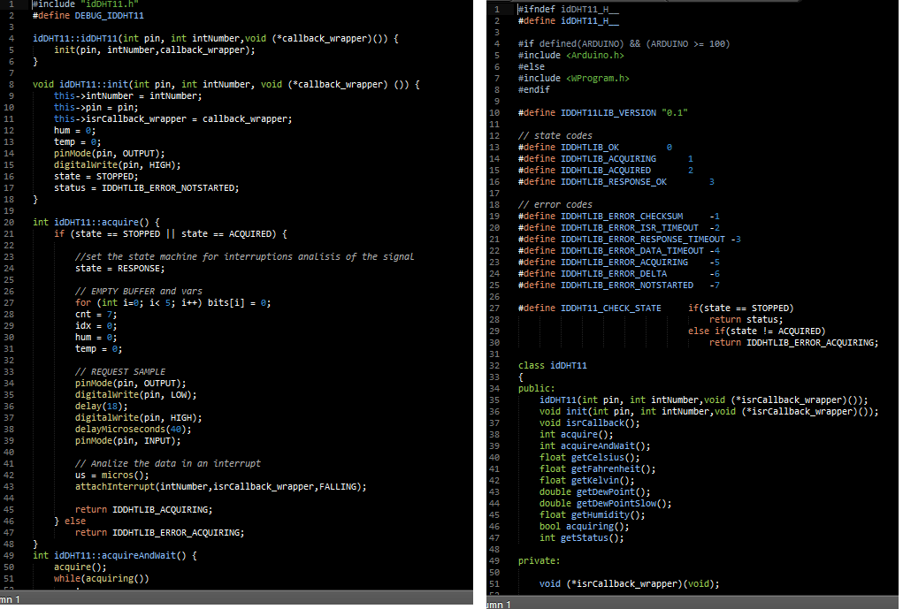

**Figure 6.1.1: Some sample code for the DHT11 Library (Courtesy of Arduino Playground (http://playground.arduino.cc/Main/DHT11Lib))**

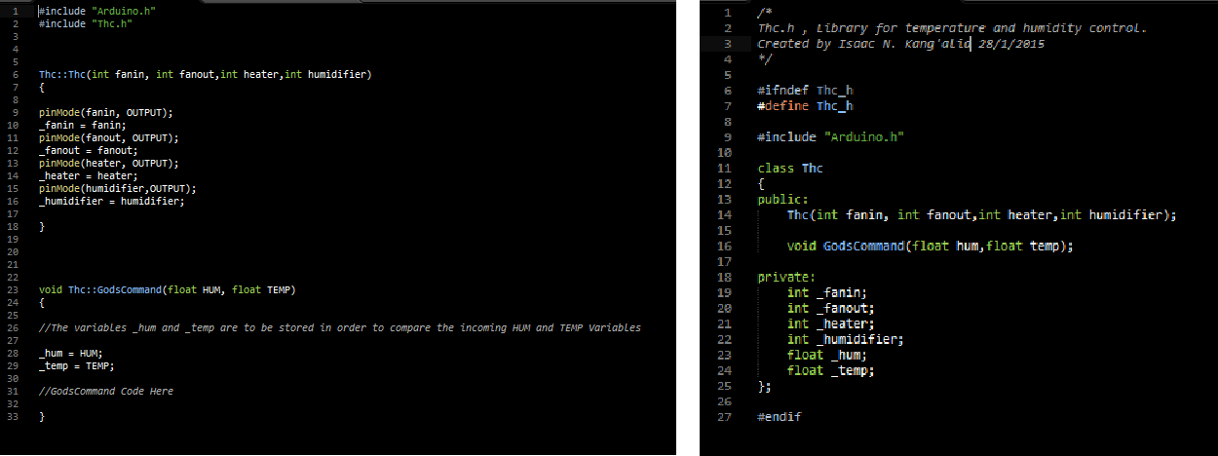

**Figure 6.1.2: My custom library (WIP) - the clock**